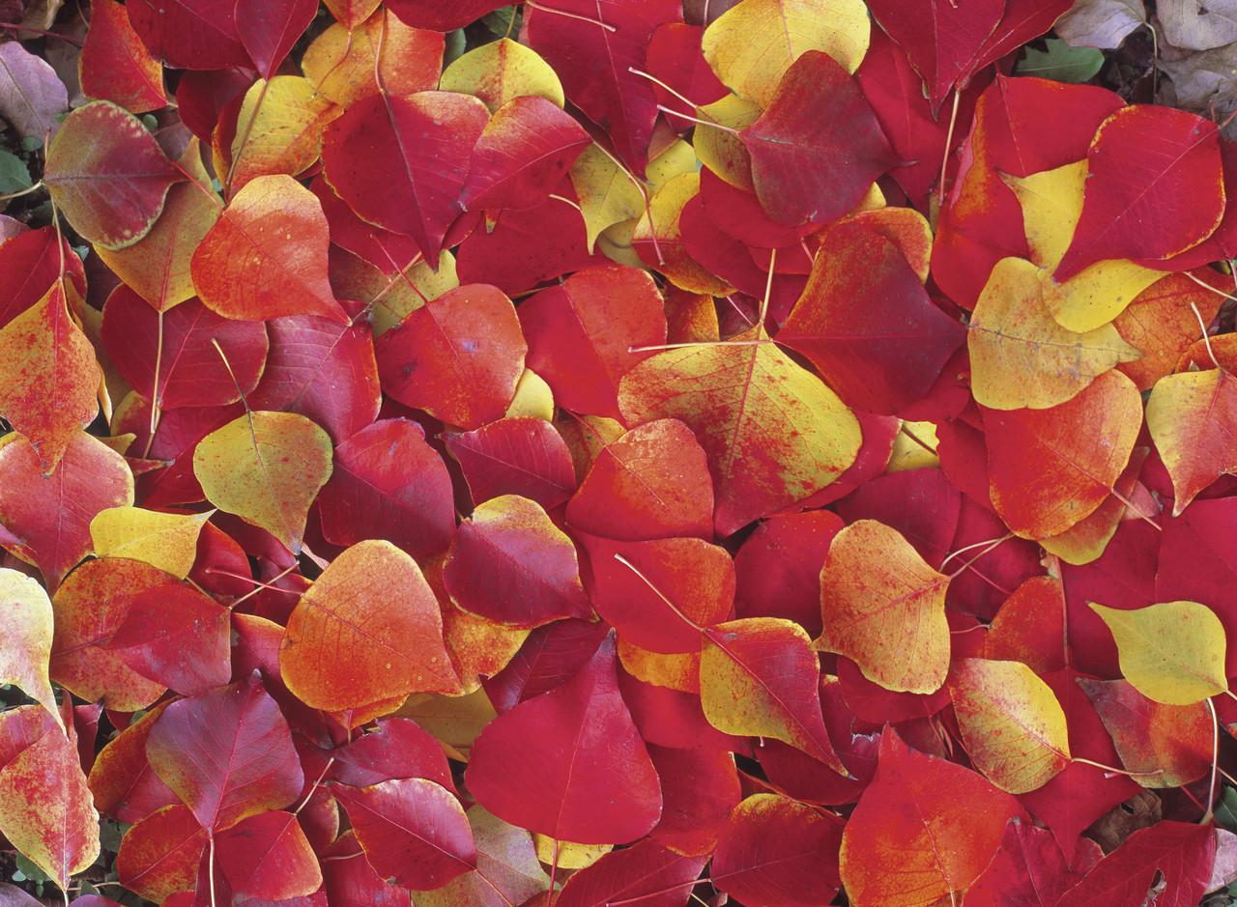
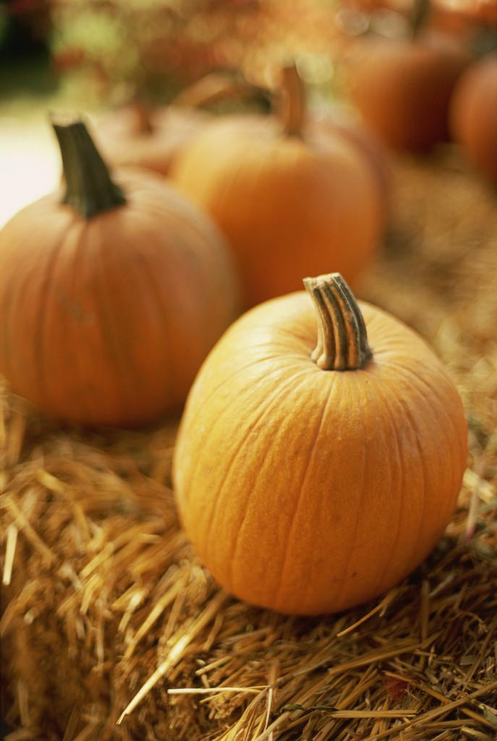
Mrs. Glaser’s Third Grade News
October 18, 2019

Dear Parents and Students,

I guess it is fall! Time to gather up the warm clothing! Please remember to send and have your child wear layers. They can always take clothing off, but if they are cold, it is hard for them to warm up without anything to put on.

Thank you for contacting me in regards to having questions about your child’s progress reports. It is good to hear from you and answer any questions you may have about your child. It is amazing how much better your child works when they know we communicate about what they are doing at home and at school. Anytime you want to know something please feel to contact me! I will be happy to share information about their progress with you!

We are continuing to work on multiplication and division facts and this week we focused on 4s. Please make sure they are keeping up with these. They must have both multiplication and division mastered/ memorized by the end of 3rd grade.

Every night your child will have reading, math and spelling to do. Please check that they have done their work as some have been coming to school with their reading and math not completed. A sheet will be given to them daily for spelling to help your child improve their cursive and to practice writing their spelling words correctly. Often they can say them out loud correctly, but when it comes to putting it on paper they forget or add letters. They have time to work on it at school but may need to finish it at home.

We had a Responsibility activity this week. Ask your child about it and what they learned!

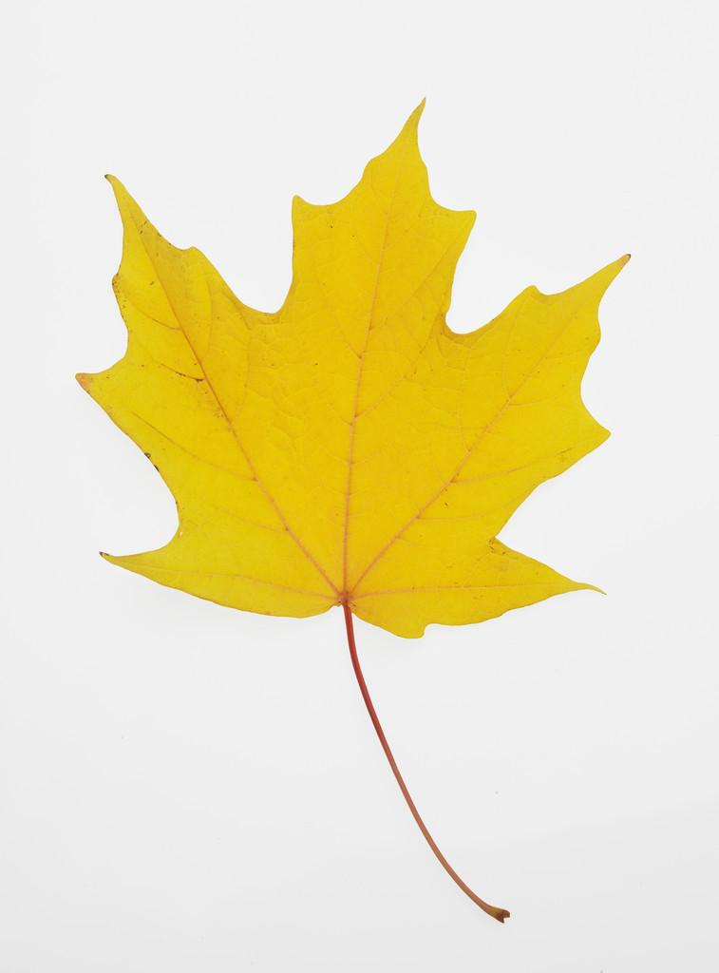
Red Ribbon Week Dress up Days All Next week!
Spooky Story Night Oct. 30@ 6:00
October 31st Black and Orange Day
Class Party October 31

